COLLABORATION PLAN

OF UNIVERSITÉ LAVAL
FOR RESEARCH TRAINING
AT THE MASTER
OR DOCTORATE LEVELS

Between the student and his/her research supervisor

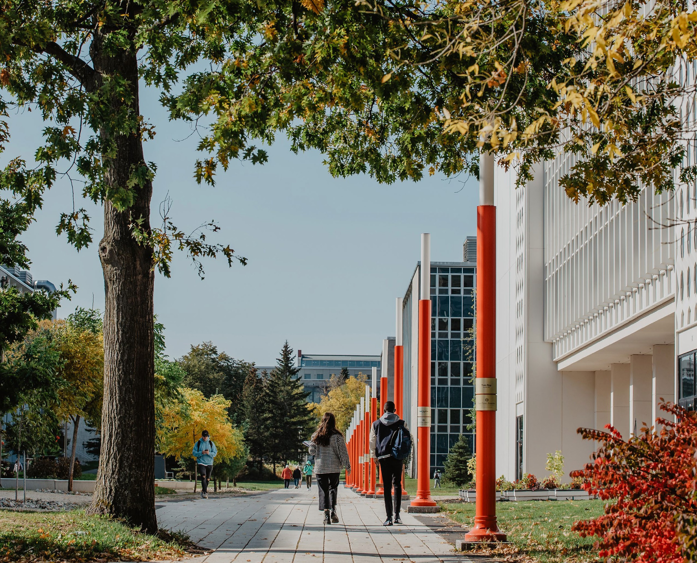

FOR RESEARCH TRAINING AT THE MASTER

OR DOCTORATE LEVELS
Between the student and his/her research supervisor

The purpose of the collaboration plan is to support the student's success in a research training program, and to ensure that the student's progress is monitored according to the specified time limits. The Academic Regulations provide for the use of a collaboration plan, which is a document testifying to the agreement established between the student and his or her research supervisor and, where applicable, his or her co-supervisor.

This model collaboration plan proposed by Université Laval's Faculty of Graduate and Postdoctoral Studies (FESP) has been developed in accordance with the Academic Regulations. It may be adapted to suit specific situations or program requirements.

The collaboration plan is drawn up jointly, at a compulsory meeting held as soon as possible or, at the latest, before the end of the first year of study. It provides a basis for defining mutual expectations and responsibilities, and for formalizing a fruitful and satisfactory work organization.
The collaboration plan specifies the stages in the program of study, the completion of research activities and the writing of a Master's or Doctoral thesis. It may include activities to develop the skills needed to carry out the student's training and professional development project.

The student's main responsibility is to be actively involved in his or her program of study and in the research training activities leading to the production of his or her Master's or Doctoral thesis.

The research supervisor accompanies and supports the student's intellectual development. He/she supervises students' work, monitors his/her progress and ensures the scientific quality of his/her work.

Specific responsibilities of the supervisor are described in the Supervision Policy (in French only) and on the Faculty of Graduate and Postdoctoral Studies’ website.

The collaboration plan must be reviewed annually by mutual agreement, in particular to assess progress. It can also be modified at any time, to take account of developments in the research project or other events unforeseen at the time the plan was drawn up.

This model is divided into three sections.

Regulatory plan - Pages 3 to 5 

This section is the heart of the collaboration plan. It should be completed first.

Additional information - Pages 6 to 7  

This section is intended to provide information on additional issues that may affect and influence the research project. Additional space is included for completing the collaboration plan if necessary.

Annual reviews - Pages 8 to 11 

This section is to be completed during the annual review.

IDENTIFICATION OF PERSONS INVOLVED
STUDENT

First and last names

Identification number (NI)

Master’s Degree / Doctorate

Study program

First program session

Preferred enrolment mode: full-time / part-time

Program director

PEOPLE RESPONSIBLE FOR SUPERVISION

Research supervisor

Research co-supervisor (if applicable)

Supervisory committee members (if applicable)

SUBJECT AND PRELIMINARY SUMMARY OF THE RESEARCH PROJECT

MASTER'S OR DOCTORAL THESIS REQUIREMENTS
- EDITING LANGUAGE
☐ French
☐ Partially in another language (e.g. including an article in English)
☐ Entirely in another language: please specify

Comments and clarifications

- MASTER'S OR DOCTORAL THESIS FORMAT
☐ To be determined subsequently
☐ Traditional (monograph)
☐ Article based*
☐ Combined*
☐ Portfolio format thesis
* In these types of Master's and Doctoral theses, each article must be written by the student in accordance with the rules laid down by the FESP or specific to the program. If the article is coauthored, please give details in section 12 below.

Comments

RESEARCH ETHICS
Declaration of research ethics and, if applicable, verification with the CÉRUL or the Comité de protection des animaux (CPAUL) if the project requires ethical approval.

TIMEFRAME OF MILESTONES AND ACTIVITIES
For example: preparatory or complementary studies, if applicable; enrolment in program courses; submission of research project; milestones in research project, research and writing activities, initial submission of thesis, etc.

SUPERVISION AND SUPPORT ARRANGEMENTS
For example: frequency and conditions for meetings, follow-up procedures (deadlines for submitting texts before meetings, deadlines for correction or feedback on writing work, evaluation of work progress), etc. For co-supervisor, complete the section on the next page.

FURTHER CLARIFICATION OF ROLES AND RESPONSIBILITIES

For example: hours of attendance normally required, declaration of job-related activities, role of the research supervision in the design of the research project, availability for meetings other than those scheduled, etc.

IN A CO-SUPERVISION CONTEXT, IF APPLICABLE
For example: respective tasks and areas of expertise, operating procedures for follow-up and meetings, particularities in terms of the resources offered by supervisor and co-supervisor and the sharing of intellectual property, etc.

SUPERVISORY COMMITTEE, IF APPLICABLE
For example: role of the committee, frequency of meetings, participation in the evaluation of the Master's or Doctoral thesis, or doctoral exam, etc.

SPECIAL CIRCUMSTANCES AFFECTING THE ACADEMIC PATH

DATE OF THE MEETING TO ESTABLISH A COLLABORATION PLAN

We confirm that we have consulted each other in order to establish this collaboration plan.

The student - date

Research supervisor - date

Research co-supervisor, if applicable - date

ADDITIONAL SECTIONS (9 TO 14)

TO BE COMPLETED IF RELEVANT

INVOLVEMENT IN SCIENTIFIC LIFE
For example: participation in research center activities, research seminars, symposiums or congresses; presentation of papers, writing of scientific articles, etc.

STUDY FINANCING AND WORKING CONDITIONS
For example: merit scholarships, research grants, research or teaching assistantships, other on-campus employment, Faculty of Graduate and Postdoctoral Studies Student Success Scholarships, faculty scholarships, etc.

MATERIAL RESOURCES
For example: access to a workstation, a computer, a laboratory, databases, results of previous research, to other equipment, computer licenses; field expenses, insurance, photocopies, conference attendance, etc.

INTELLECTUAL PROPERTY,
WITH OR WITHOUT JOINT PUBLICATION
  - Among other things to be discussed, the use of copyright material and ways of sharing research results.

  - In the case of joint publication, details of acknowledgement and order of coauthors, as well as intellectual property rights. The authorization of coauthors must be obtained while the article is being written. The coauthor authorization form must be completed and transmitted at the time of initial submission. If the article is published at the time of initial submission, authorization must be obtained from the publisher. Please note that any article inserted in a Master's thesis or Doctoral thesis must be written by the student in accordance with the rules laid down by the FESP or specific to the program.

CONFIDENTIALITY OR PARTNERSHIP AGREEMENT
For example: special arrangements in the context of subsidized or contract research, including or not the signing of institutional forms to be attached to the initial submission.

ADDITIONAL TRAINING
Extra-curricular activities.

EXPECTED LANGUAGE SKILLS
French: ☐ spoken  ☐ read  ☐ written 
English:  ☐ spoken  ☐ read  ☐ written
Other language ☐ spoken  ☐ read ☐ written

Means used to develop skills

PROFESSIONAL DEVELOPMENT
For example: courses in professional development, relevant to the student's training objectives, such as the training offered by the FESP, which covers skills development, oral communication, academic and professional writing, project management, various aspects of university pedagogy, etc.

Other activities

UPDATING THE COLLABORATION PLAN

YEAR 2 ANNUAL REVISION 20 -20

MODIFICATIONS TO THE INITIAL PLAN, IF ANY

STATE OF PROGRESS
Research and writing, development of research skills, academic and scientific achievements, etc.

SELF-ASSESSMENT

COMMENTS FROM RESEARCH SUPERVISOR

IN A CO-SUPERVISION CONTEXT, COMMENTS FROM THE CO-SUPERVISOR

OBJECTIVES FOR THE COMING YEAR
Research project progress, academic and scientific achievements, writing schedule, etc.

UPDATING THE COLLABORATION PLAN

YEAR 3 ANNUAL REVISION 20 -20

MODIFICATIONS TO THE INITIAL PLAN, IF ANY

STATE OF PROGRESS
Research and writing, development of research skills, academic and scientific achievements, etc.

SELF-ASSESSMENT

COMMENTS FROM RESEARCH SUPERVISOR

IN A CO-SUPERVISION CONTEXT, COMMENTS FROM THE CO-SUPERVISOR

OBJECTIVES FOR THE COMING YEAR
Research project progress, academic and scientific achievements, writing schedule, etc.

UPDATING THE COLLABORATION PLAN

YEAR 4 ANNUAL REVISION 20 -20

MODIFICATIONS TO THE INITIAL PLAN, IF ANY

STATE OF PROGRESS
Research and writing, development of research skills, academic and scientific achievements, etc.

SELF-ASSESSMENT

COMMENTS FROM RESEARCH SUPERVISOR

IN A CO-SUPERVISION CONTEXT, COMMENTS FROM THE CO-SUPERVISOR

OBJECTIVES FOR THE COMING YEAR
Research project progress, academic and scientific achievements, writing schedule, etc.

UPDATING THE COLLABORATION PLAN

YEAR 5 ANNUAL REVISION 20 -20

MODIFICATIONS TO THE INITIAL PLAN, IF ANY

STATE OF PROGRESS
Research and writing, development of research skills, academic and scientific achievements, etc.

SELF-ASSESSMENT

COMMENTS FROM RESEARCH SUPERVISOR

IN A CO-SUPERVISION CONTEXT, COMMENTS FROM THE CO-SUPERVISOR

OBJECTIVES FOR THE COMING YEAR
Research project progress, academic and scientific achievements, writing schedule, etc.

